NETWORK DEVICES
- Draw and label a simple home network diagram showing a router, switch, and three devices (like a laptop, smartphone, and smart TV), indicating how each device connects to the network.
Answer
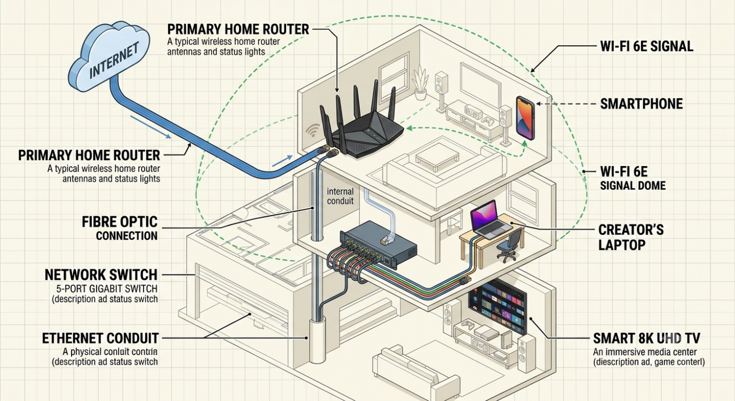

- Create a comparison table listing at least four network devices (router, switch, hub, access point) and describe one real-world use case for each, referencing apps or services you use daily (e.g., Wi-Fi for streaming on YouTube, LAN gaming, etc.).
Answer
Network Devices: Functions and Real-World Use Cases
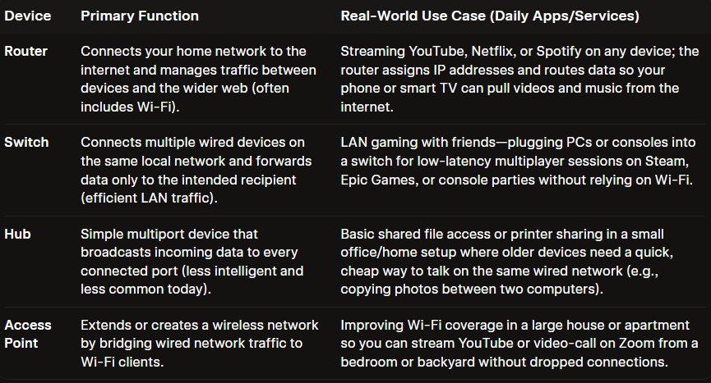

How this maps to daily use
- Router: Everything that touches the Internet (YouTube, Chrome, online games, Zoom) passes through the router, which also hands out local IPs via DHCP.
- Switch: Wired, performance-sensitive devices (gaming PC, console, workstation) plug into a switch for stable, low-latency connections on the same LAN.
- Hub: Mostly educational/troubleshooting; you might see it in a lab where an instructor wants all students’ packets visible on every port for analysis.
- Access Point: Pure Wi-Fi extension—ideal when you need more wireless coverage for phones, tablets, and smart TVs without changing your router’s IP scheme.

- Write a short scenario where you explain how data travels from your phone to the internet when you order food on Zomato, mentioning the role of each network device involved (router, switch, access point).
Answer
Scenario: Ordering food on Zomato from your phone
You open the Zomato app on your smartphone and tap “Place Order.” Your phone creates a data packet containing the order details and encrypts it.
Because you’re on Wi-Fi, the packet is sent wirelessly to the nearest access point. The access point’s job is to receive the radio signal from your phone and convert it into a wired Ethernet signal.
That Ethernet cable from the access point plugs into a switch. The switch looks at the packet’s destination address and forwards it only to the correct port — the one connected to the router — instead of flooding it to every device on the network.
The router receives the packet from the switch. It checks its routing table, translates your private home IP address into a public one (NAT), and sends the packet out through your modem to your ISP and ultimately across the internet to Zomato’s servers.
A few moments later the confirmation (or the “restaurant accepted your order” notification) travels back along the reverse path: internet → router → switch → access point → your phone.

- Given this situation: you have a Wi-Fi router, but your gaming PC only has an Ethernet port and is far from the router. Suggest two different network devices you could use to connect your PC to the internet and explain how each would work in this setup. Think about devices like switches, powerline adapters, or Wi-Fi extenders.
Answer
Option 1: Powerline Ethernet Adapter Kit
A Powerline adapter uses your home's existing electrical wiring to send internet data through the walls.
- How it Works:
  - Plug the first Powerline adapter into a wall outlet near your Wi-Fi router and connect it to the router using an Ethernet cable.
  - Plug the second Powerline adapter into a wall outlet near your gaming PC and connect it directly to your PC's Ethernet port using a second cable.
  - The two adapters pair with each other automatically, using the copper electrical lines inside your home to bridge the connection between your router and PC.
- Why it's great for gaming: Powerline connections often provide lower and more consistent latency (ping) than wireless extensions, which is crucial for competitive online gaming.
Option 2: Wi-Fi Extender / Bridge (with an Ethernet Port)
A Wi-Fi extender with an Ethernet port catches the wireless signal from your main router and converts it back into a wired connection.
- How it Works:
  - Place the Wi-Fi Extender in the same room as your gaming PC (or halfway, where the Wi-Fi signal is still strong) and pair it wirelessly with your main Wi-Fi router.
  - Plug an Ethernet cable into the Ethernet output port on the Wi-Fi extender and run the other end directly into your PC's network port.
  - The extender acts as a "wireless bridge"—it handles the wireless communication across the long distance to the router and feeds the internet data directly into your PC via the cable.
- Why it's great for gaming: It bypasses the need for a Wi-Fi card inside your PC, and newer Wi-Fi 6 extenders offer very reliable bandwidth for downloading large game files.

